ISOM 3260

Database Design and Administration

Spring 2018

**Team Project Report**

TasteCHA | (Group Number: 305)

|  |  |
| --- | --- |
| Cheung Hiu Lam Emry | 20354873 |
| Li Hiu Ting | 20342155 |
| Tsui Tsz Wai | 20341606 |
| Lam Sin Yi | 20384581 |
| Pang Cheuk Ling | 20346400 |
| Tsue Yin Ting | 20356792 |

1. **Introduction**

Our team of six IT consultants and developers have developed a Point of Sales (POS) system for the company, TasteCHA, which sells beverages.

After gathering and understanding their requirements, we have developed a conceptual data model to understand various entities, attributes and their relationships. A logical data model is drawn to transform the entity relationship diagram (ERD) into relations. A data dictionary is further illustrated to design databases stored in Oracle SQL Server. Below you may find the details of the components mentioned above.

Currently, our product is an POS system, which allows staff to make orders and customers to browse and buy products right away in the self-service kiosk. Staff members will also have control the production process and overlook the operational efficiency of the company.

1. **Conceptual data model**

E-R Diagram

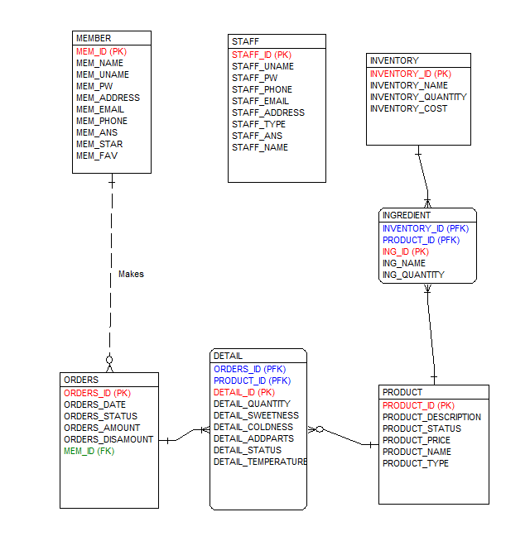

As POS system, Group 5 TasteCHA on two important groups for its continued success: customers and staffs.

Members have MEM_ID, MEM_NAME, MEM_UNAME, MEM_PW, MEM_ADDRESS, MEM_EMAIL, MEM_PHONE, MEM_ANS (answer for safety question), MEM_STAR and MEM_FAV

Member can make as many orders as possible. Members can also make no orders at all. Orders have ORDER_ID, ORDER_DATE, ORDER_TIME and ORDER_STATUS, ORD_DISAMOUNT and MEM_ID as of storing corresponding member who makes the order. Each order belongs to one and only one customer. Each order can contain many products, but there must be at least one product in each order. Some drinks may be unpopular among customer and thus are not added in any DETAIL or ORDERS at all.

Each Order has at least one DETAIL, which stores the information of drink that ordered by member. Each Detail belongs to one and only one orders. DETAIL has the following attribute: DETAIL_ID, DETAIL_QUANTITY, DETAIL_SWEETNESS, DETAIL_TEMPERATURE, DETAIL_COLDNESS, DETAIL_ADDPARTS, DETAIL_STATUS. EACH DETAIL belongs to one product. And, one product can belong to zero to many detail. As its many-to-many relationship between ORDERS and PRODUCT, we assign it as an associative entity

Product have PRODUCT_ID, PRODUCT_DESCRIPTION, PRODUCT_STATUS, PRODUCT_PRICE, PRODUCT_NAME and PRODUCT_TYPE.

INGREDIENT is stored as a associative entity to indicate each ingredients in each product, with ING_ID, ING_NAME, ING_QUANTITY, INVENTORY_ID (PFK), PRODUCT_ID(PFK). INVENTORY have the attributes of INVENTORY_ID, INVENTORY_NAME,INVENTORY_QUANTITY and INVENTORY_COST. INGREDIENT could belong to one inventory and inventory could belong to many ingredients.

Other than MEMBER, we only store staff record IN STAFF entity, including STAFF_ID, STAFF_UNAME, STAFF_NAME, STAFF_PW, STAFF_PHONE, STAFF_ADDRESS, STAFF_EMAIL,STAFF_TYPE, STAFF_ANS.

1. **Logical data model**

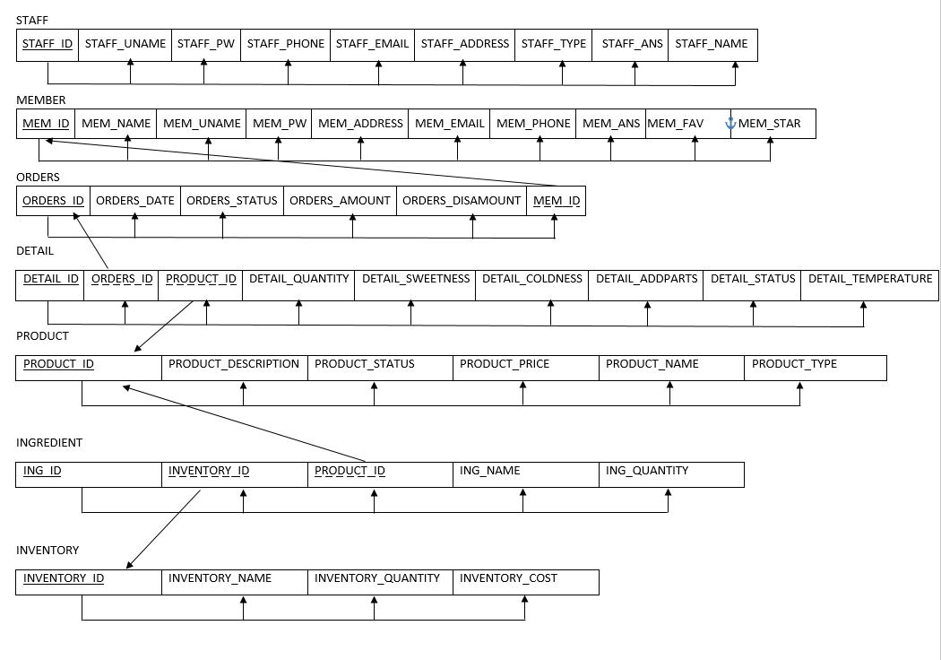

1. **Data dictionary**

|  |  |  |  |  |  |  |
| --- | --- | --- | --- | --- | --- | --- |
| **Entity: DETAIL** | | | | | | |
| Attributes | Datatype | PK | FK | Length | NULL | Description |
| ORDERS_ID | NUMBER |  | ✓(PFK) | 20,0 | FALSE | Unique identifies order |
| PRODUCT_ID | NUMBER |  | ✓(PFK) | 20,0 | FALSE | Unique identifies product |
| DETAIL_ID | NUMBER | ✓ |  | 20,0 | FALSE | Unique identifies detail |
| DETAIL_QUANTITY | NUMBER |  |  | 20,0 | FALSE | Number of drink per detail |
| DETAIL_SWEETNESS | VARCHAR2 |  |  | 20 | TRUE | Sweetness of a drink |
| DETAIL_COLDNESS | VARCHAR2 |  |  | 20 | TRUE | Coldness of a drink |
| DETAIL_ADDPARTS | VARCHAR2 |  |  | 20 | TRUE | Extra topping of drink in a detail |
| DETAIL_STATUS | VARCHAR2 |  |  | 30 | FALSE | Production stage of drink in a detail |
| DETAIL_TEMPERATURE | VARCHAR2 |  |  | 20 | TRUE | Temperature of drink in a detail |

|  |  |  |  |  |  |  |
| --- | --- | --- | --- | --- | --- | --- |
| **Entity: INGREDIENT** | | | | | | |
| Attributes | Datatype | PK | FK | Length | NULL | Description |
| INVENTORY_ID | NUMBER |  | (PFK)✓ | 20 | FALSE | Uniquely identifies inventory |
| PRODUCT_ID | NUMBER |  | (PFK)✓ | 20 | FALSE | Uniquely identifies product |
| ING_ID | NUMBER | ✓ |  | 20 | FALSE | Uniquely identifies ingredient |
| ING_NAME | VARCHAR2 |  |  | 30 | FALSE | Quantity of a ingredient |
| ING_QUANTITY | VARCHAR2 |  |  | 10 | FALSE | Quantity of a ingredient needed for preparing a drink |

|  |  |  |  |  |  |  |
| --- | --- | --- | --- | --- | --- | --- |
| **Entity: INVENTORY** | | | | | | |
| Attributes | Datatype | PK | FK | Length | NULL | Description |
| INVENTORY_ID | NUMBER | ✓ |  | 20 | FALSE | Uniquely identifies inventory |
| INVENTORY_NAME | VARCHAR2 |  |  | 30 | FALSE | Name of inventory |
| INVENTORY_QUANTITY | NUMBER |  |  | 20 | FALSE | Quantity of inventory |
| INVENTORY_COST | NUMBER |  |  | 20,2 | TRUE | Unit cost of a inventory |
| INVENTORY_STATUS | VARCHAR2 |  |  | 20 | TRUE | Availability of inventory |

|  |  |  |  |  |  |  |
| --- | --- | --- | --- | --- | --- | --- |
| **Entity: MEMBER** | | | | | | |
| Attributes | Datatype | PK | FK | Length | NULL | Description |
| MEM_ID | NUMBER | ✓ |  | 20 | FALSE | Uniquely identifies member |
| MEM_NAME | VARCHAR2 |  |  | 30 | FALSE | Name of member |
| MEM_UNAME | VARCHAR2 |  |  | 20 | FALSE | Username of member |
| MEM_PW | VARCHAR2 |  |  | 20 | FALSE | Password |
| MEM_ADDRESS | VARCHAR2 |  |  | 100 | TRUE | Mailing address of member |
| MEM_EMAIL | VARCHAR2 |  |  | 50 | TRUE | Email of member |
| MEM_PHONE | VARCHAR2 |  |  | 20 | FALSE | Phone number of member |
| MEM_ANS | VARCHAR2 |  |  | 50 | FALSE | Answer of safety question when he forgets password |
| MEM_STAR | NUMBER |  |  | (20,2) | FALSE | The redemption point available for member |
| MEM_FAV | VARCHAR2 |  |  | 30 | FALSE | The favourite drink type of member |

|  |  |  |  |  |  |  |
| --- | --- | --- | --- | --- | --- | --- |
| **Entity: ORDERS** | | | | | | |
| Attributes | Datatype | PK | FK | Length | NULL | Description |
| ORDERS_ID | Number | ✓ |  | 20,0 | FALSE | Uniquely identifies order |
| ORDERS_DATE | Date |  |  | 20 | FALSE | Date when the order is placed |
| ORDERS_STATUS | Varchar2 |  |  | 30 | FALSE | Show whether the order is processing/completed |
| MEM_ID | Number |  | ✓ | 20,0 | FALSE | Uniquely identifies member. It shows which member places which order. |
| ORDERS_AMOUNT | Number |  |  | 20,2 | FALSE | The total money amount of an order |
| ORDERS_DISAMOUNT | Number |  |  | 20,2 | FALSE | The total money amount of an order the member should pay after redemption |

|  |  |  |  |  |  |  |
| --- | --- | --- | --- | --- | --- | --- |
| **Entity: PRODUCT** | | | | | | |
| Attributes | Datatype | PK | FK | Length | NULL | Description |
| PRODUCT_ID | Number | ✓ |  | 20,0 | FALSE | Uniquely identifies product |
| PRODUCT_DESCRIPTION | Varchar2 |  |  | 100 | FALSE | Brief description of each product |
| PRODUCT_STATUS | Varchar2 |  |  | 20 | FALSE | Show the availability of each product |
| PRODUCT_PRICE | Number |  |  | 5,2 | FALSE | Price of each product |
| PRODUCT_NAME | Varchar2 |  |  | 30 | FALSE | Name of each product |
| PRODUCT_TYPE | Varchar2 |  |  | 20 | FALSE | Category of the product belongs to |

|  |  |  |  |  |  |  |
| --- | --- | --- | --- | --- | --- | --- |
| **Entity: STAFF** | | | | | | |
| Attributes | Datatype | PK | FK | Length | NULL | Description |
| STAFF_ID | Number | ✓ |  | 20 |  | Uniquely identifies staff |
| STAFF_UNAME | VARCHAR2 |  |  | 50 | FALSE | Username of staff |
| STAFF_PW | Number |  |  | 38 |  | Password of staff |
| STAFF_PHONE |  |  |  | 30 |  | Phone number of staff |
| STAFF_EMAIL | VARCHAR2 |  |  | 100 |  | Email of staff |
| STAFF_ADDRESS | VARCHAR2 |  |  | 200 |  | Mailing address of staff |
| STAFF_TYPE | VARCHAR2 |  |  | 20 | FALSE | The job position of staff |
| STAFF_ANS | VARCHAR2 |  |  | 30 | FALSE | Answer of safety question when he forgets password |
| STAFF_NAME | VARCHAR2 |  |  | 50 | FALSE | Name of staff |

1. **Functional Requirements**

**Staff**

1. Cashier

1. Allow staff to insert new product information

2. Allow staff to update product information

3. Allow staff to update order status for orders

4. Allow staff to place order for customer

5. Allow staff to conduct registration for members

6. Allow staff to retrieve the login password/reset the login password in case they have forgotten.

7. Allow staff to help customers to indicate their most favorite product type during the member registration (Bonus point: Set B)

1. Barista

1. Allow staff to update order status for order

2. Allow staff to view order list

3. Allow staff to retrieve the login password/reset the login password in case they have forgotten.

1. Manager

1. Allow manager to display “Manager Dashboard” (refer below for the manager dashboard requirement)

* Show total amount of daily and monthly sales
* Show all sales order of today (And be able to view detail of each sales order)
* Show the 5 most popular products and each of the product sales (in terms of quantity)
* Show the top 5 members and their individual sales amounts
* Show sales of a particular product, in terms of quantity sold
* Show the number of orders of different statuses

2. Allow manager to retrieve the login password/reset the login password in case they have forgotten.

**Customer**

1. Allow customers to search products and view product details

2. Allow customers to add products into shopping cart for later retrieval

3. Allow customers to view and edit the shopping cart

4. Allow customers to delete shopping cart lines

5. Allow customers to make purchase

6. Allow customers to customize their beverages

7. Allow members to earn stars at purchase time

8. Allow members to redeem rewards

9. Allow members to view best-selling product, that matched with the member’s favorite type, within 3 months and is available. (Bonus point: Set B)

1. **Conclusion**

Currently, our product is still in the preliminary stage, which provides the basic functions of a purchase system. Customers can search, view and add products in a shopping cart. Also, they can edit and customise the beverages in the shopping cart. Member can even earn stars at purchase time and redeem rewards. Member can also get recommended of a product they may be interested in.

Cashier can insert and update products and update order status. They can place order, conduct registration for member and retrieve/reset login password if they have forgotten. Barista can update order status for order, view order list and also retrieve/reset login password if they have forgotten. Managers can view manager dashboard for a summary of total daily and monthly sales, sales order of the day, five most popular products, five members with highest spending, sales of a particular product, number of orders of different statues.

Further developments are needed to improve on recommendation engines and user experience. In the long run, we should allow consumers to register by himself so as to increase more participants to join our customer loyalty programme. Apart from personalised promotion, we may notify members if new products of members’ favourite type is launched. It provides a more holistic experience to each customer.

1. **Suggestions**

REQUIREMENTS

1. *Update Status Automatically*: Order status can be updated automatically, rather than having manager manually doing it, so as to save time and resources.
2. *Manager Dashboard Graphs*: Graphs can be drawn to illustrate the reality of delivering a manager dashboard, because managers usually prefer to understand patterns and insights visually and at one glance.
3. *Customer Loyalty Management*: More push notifications and promotions can be introduced to persuade more purchases and portrait a more vivid workplace environment.

LOGISTICS

1. *Update Software Used*: Oracle Forms seems to be rather outdated. More advanced alternatives can be explored to prepare students more practically and beneficially.
2. *Testing Skills*: Some students may be confused about the proper procedures of testing. More guidelines can be given to equip students with more advanced testing skills, for example, what aspects they should focus on and how to prioritise and handle testing amendments.

USER INTERFACE

1. *Web Design*: More practices on web design can be done, for example, how to use CSS and HTML. This is to equip students with more technical skills.
2. *Mobile Compatibility*: Mobile app design can also be encouraged, so as to fit the app in different operating systems and screens.
3. **Assumptions**

CUSTOMERS

1. Customers understand what this website is about and for before registration.
2. Customers do not need to have an online feedback system and will contact our staff whenever necessary.

MEMBERS

1. Password should be not less than 5 or more than 20 number/character/symbols, including uppercase and lowercase

2. Members can reset the original password

3. Members could remember their phone number for point redemption.

4. The phone number of each member is unique.

5. If the member does not specify his or her favorite type, our system will suggest the most popular product to him.

STAFF

1. Staff members have their accounts directly created in database and do not need an additional interface for registration.
2. Staff members understand what this website is about and for before administration.
3. FRM-40100(FRM-40100: At first record): No action could be taken for this message which would exist when we scroll down the scroll and then scroll up to the first row.
4. Timer: we set the timer for refresh the data block’ VIEW_DETAIL’ every 5 seconds. (Related data block:’VIEW_DETAIL’ and ’ VIEW_DET_CASHIER)
5. Staff can reset the original password

PARTNERSHIPS

1. Suppliers have already formed partnerships with us and can supply liquor products to us.
2. Credit card companies have formed partnerships with us and can handle our transaction payments reliably.
3. All inventories are always available.

ORDER

1. Order cannot be cancelled after transaction completed.
2. Each person can only order 10 cups in each detail of a purchase.
3. Availability of products will be checked again before payment. If product is stock out, order must be cancelled before execute checkout

PRODUCT

1. The price of each product is less than $100, which means the maximum price is $99.9.